***Java and Eclipse Installation***

***1. Java installation***

***2. Eclipse installation***

1. **Java installation:**

Step 1) Using this URL download JDK Kit and install

<https://www.oracle.com/java/technologies/javase-downloads.html>

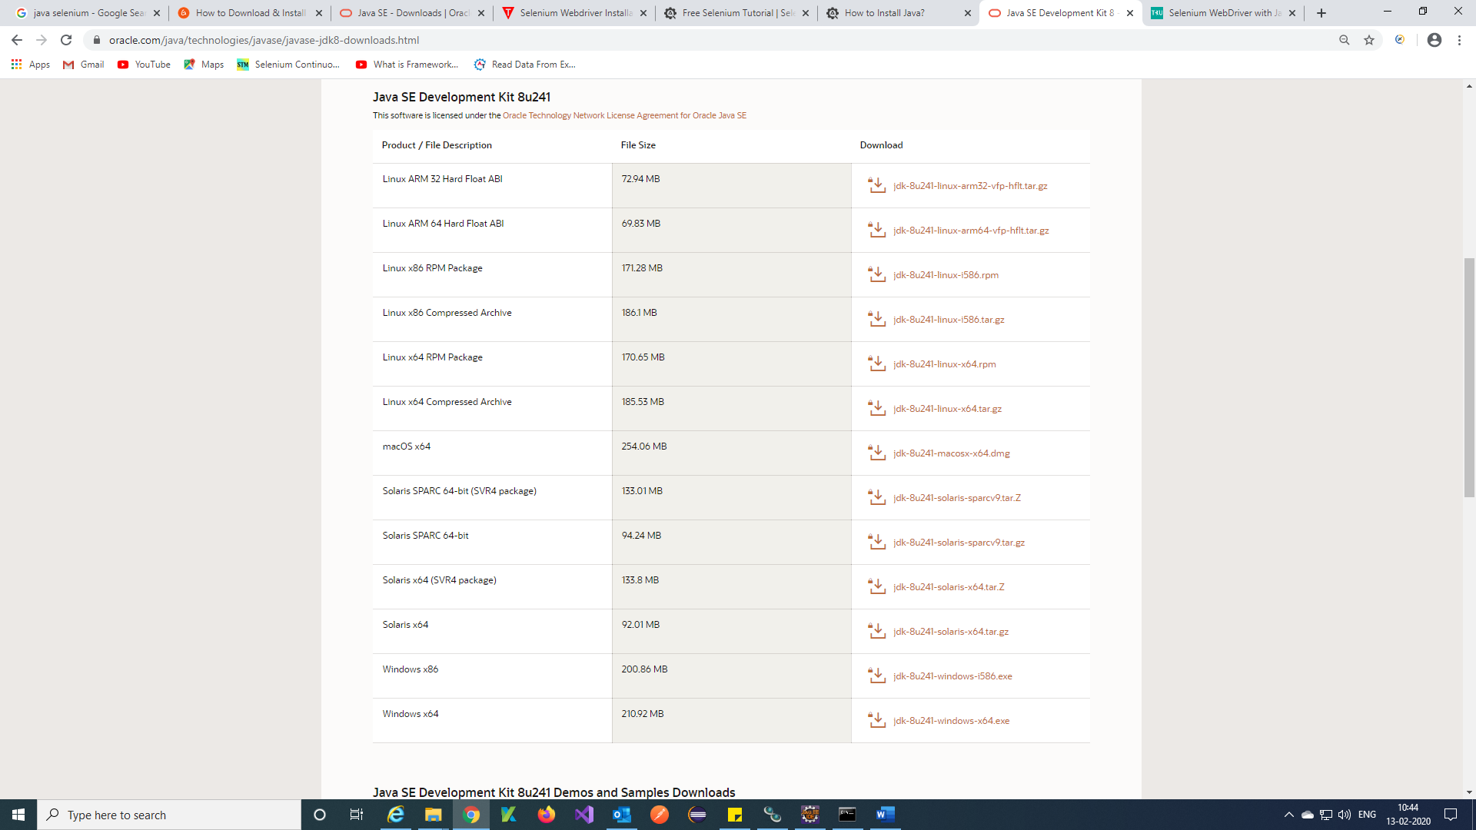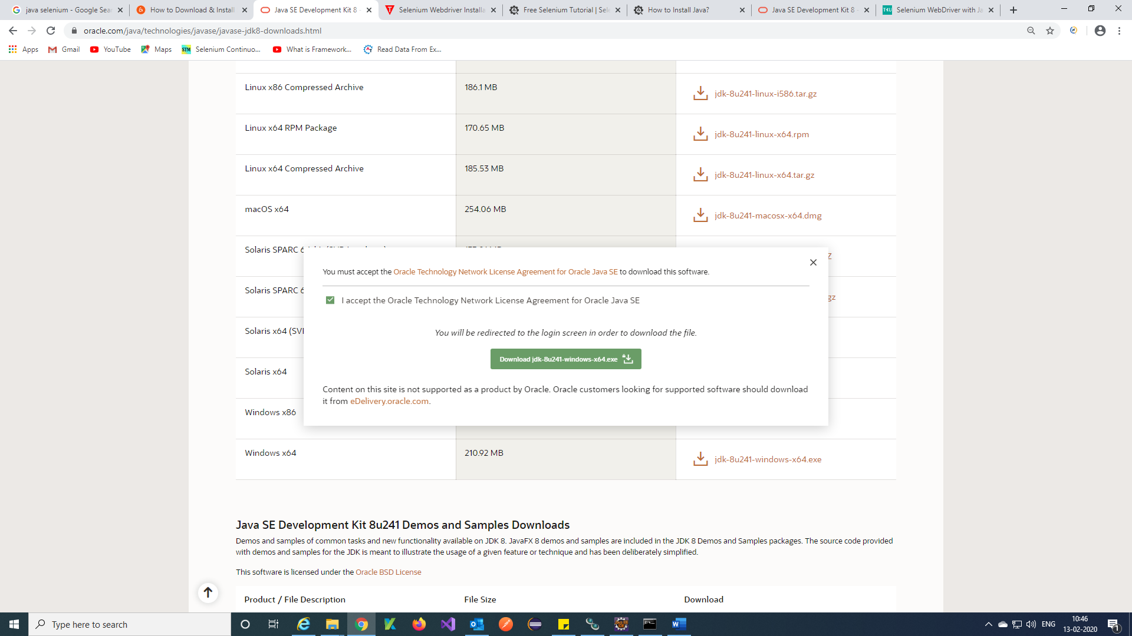

Step 2) Once you install Jdk you get below page

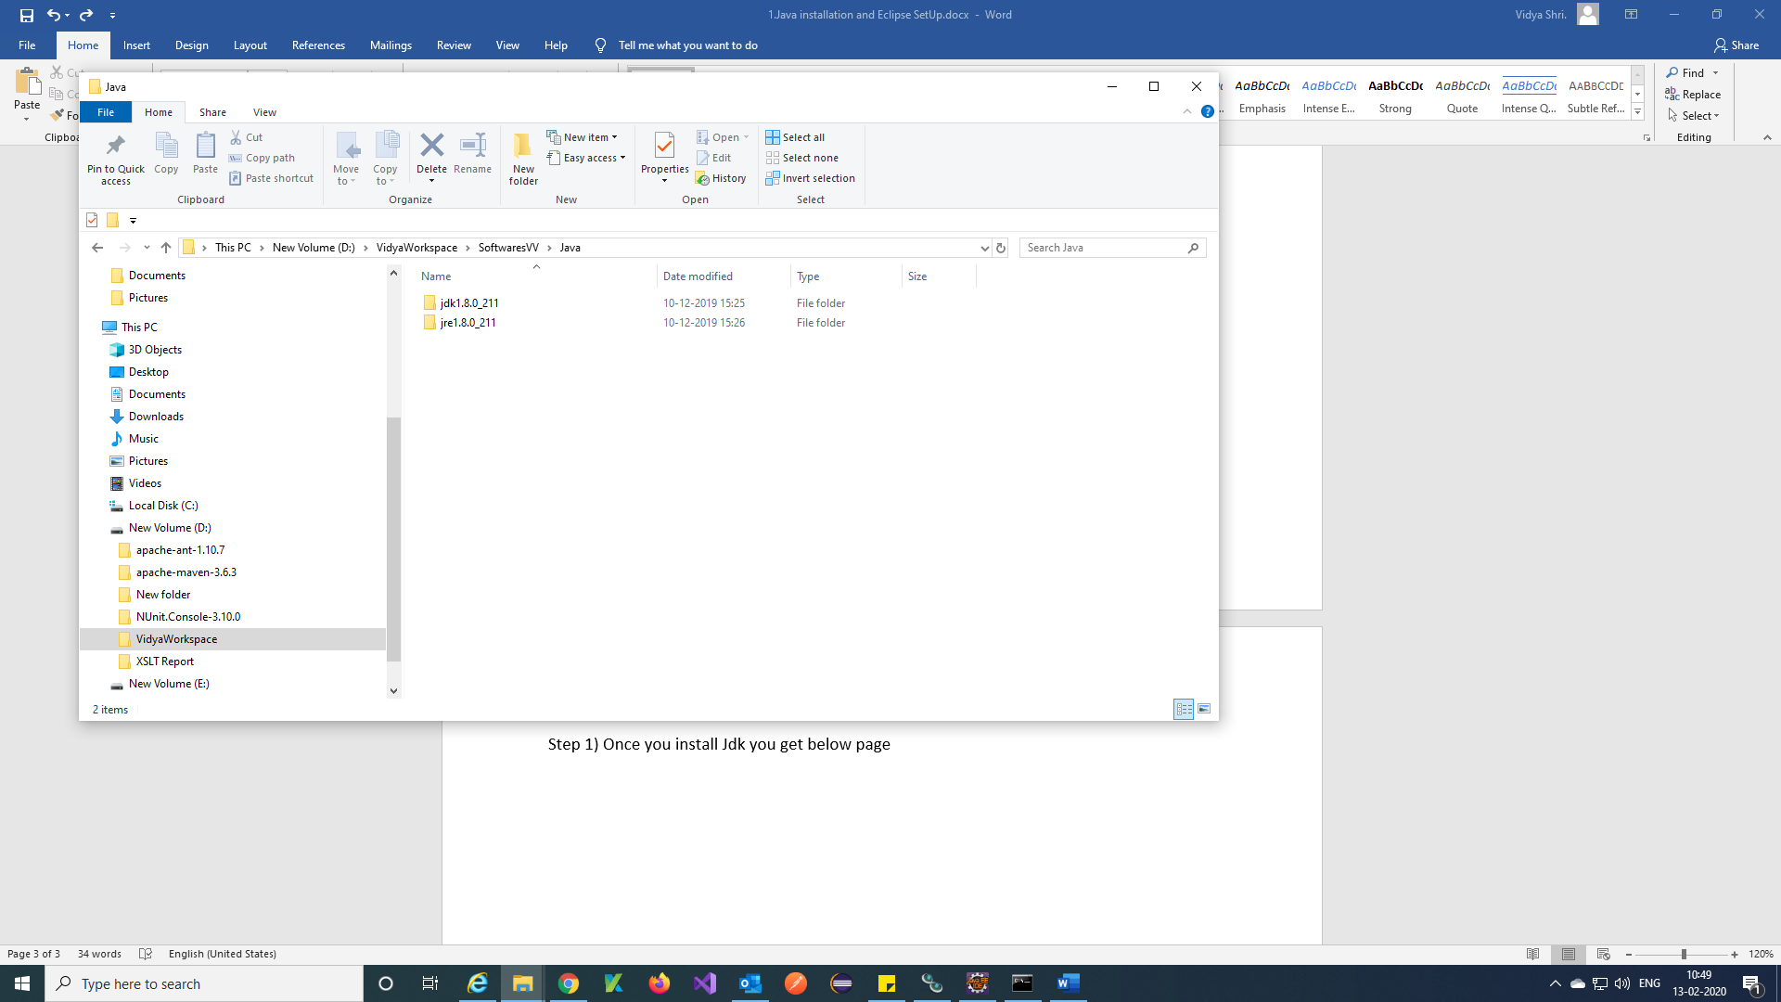

Step 3) Add jdk bin path to environments path in your system

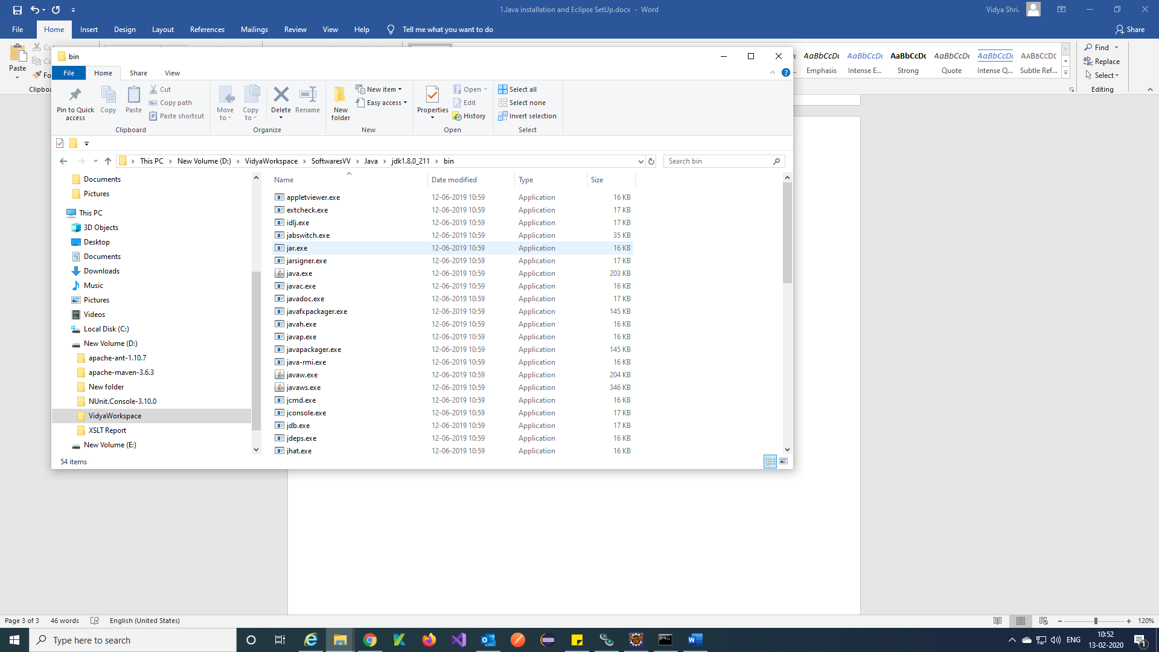

Step 4) Search view advanced system settings in System and click on Environment variables and click on path 🡪 new 🡪 Enter bin path of jdk and click on ok.

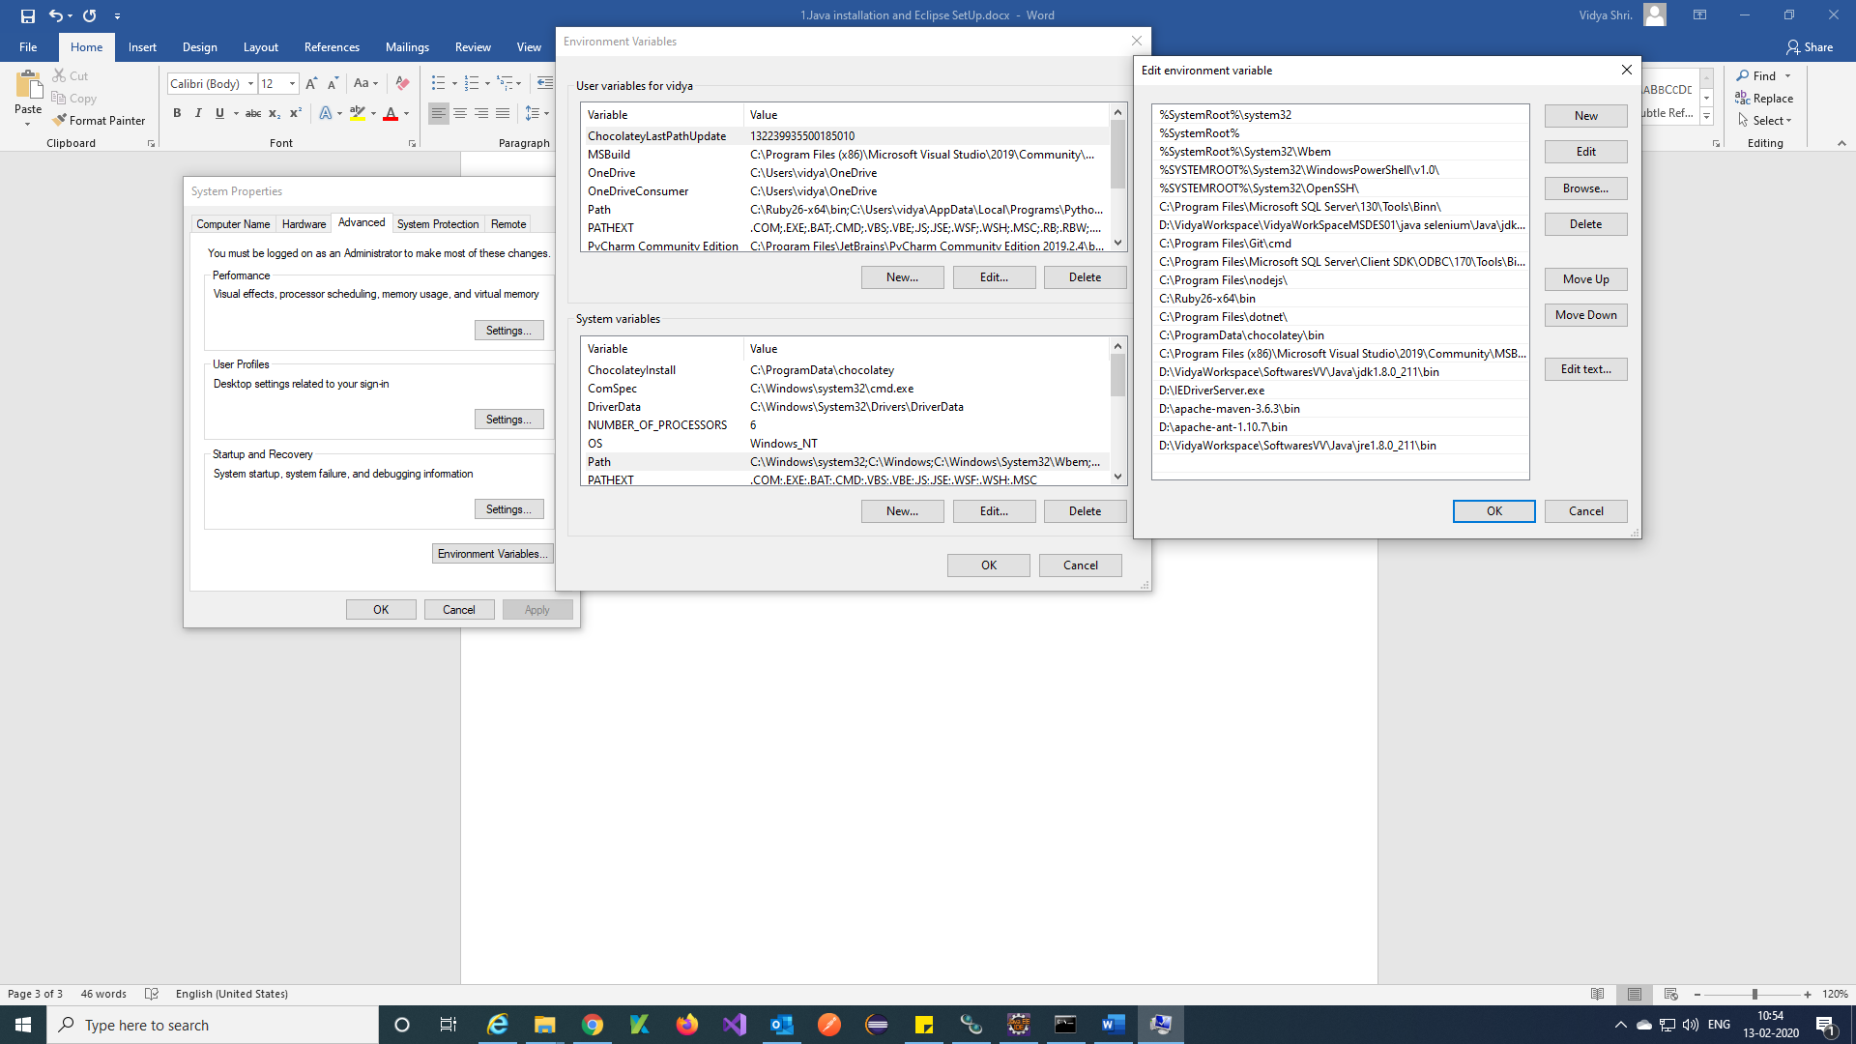

Step 5) In command prompt check java version to check java installed

Enter command = java

Enter java version command = java -version

Java compiler version command = javac -version

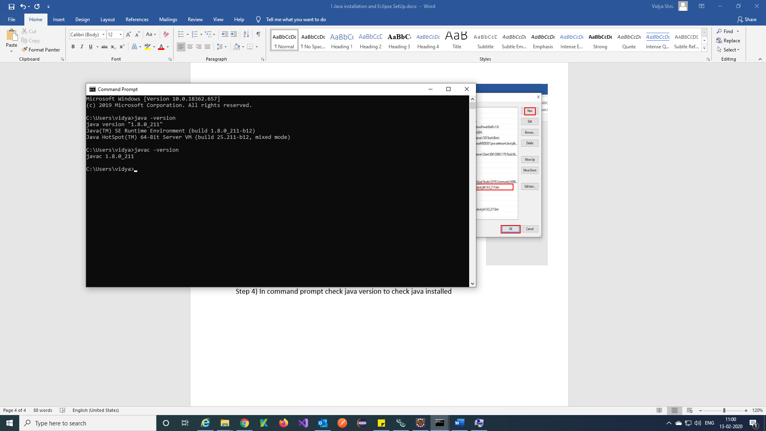

Now jdk is successfully installed into your system.

1. **Eclipse installation:**

Step 1) Using this URL download eclipse exe

<https://www.eclipse.org/downloads/packages/>

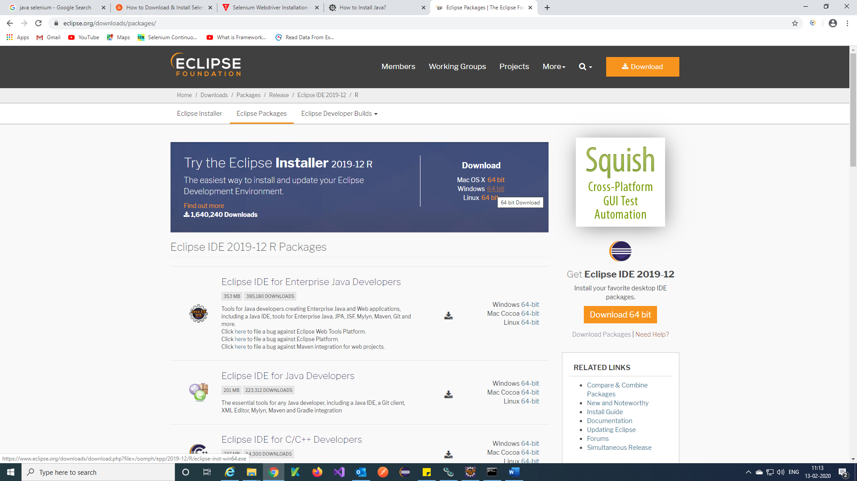

Step 2) Once after download you will get eclipse exe and double click on the eclipse exe

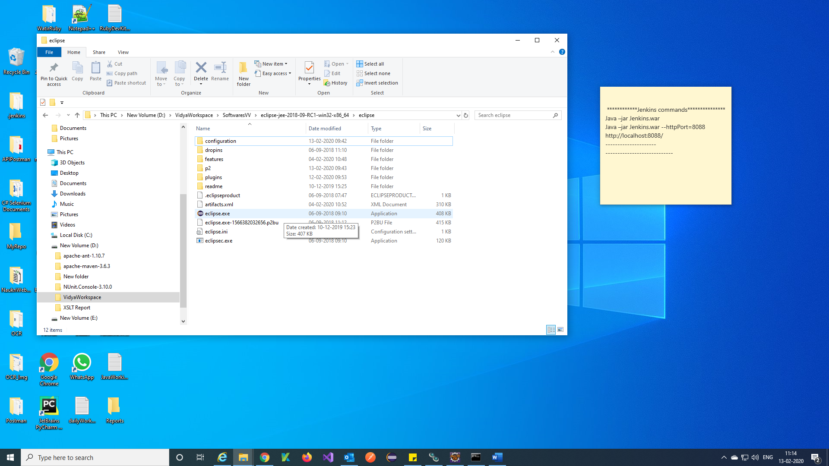

Step 3) When asked to select for a workspace, just accept the default location and click on Launch.

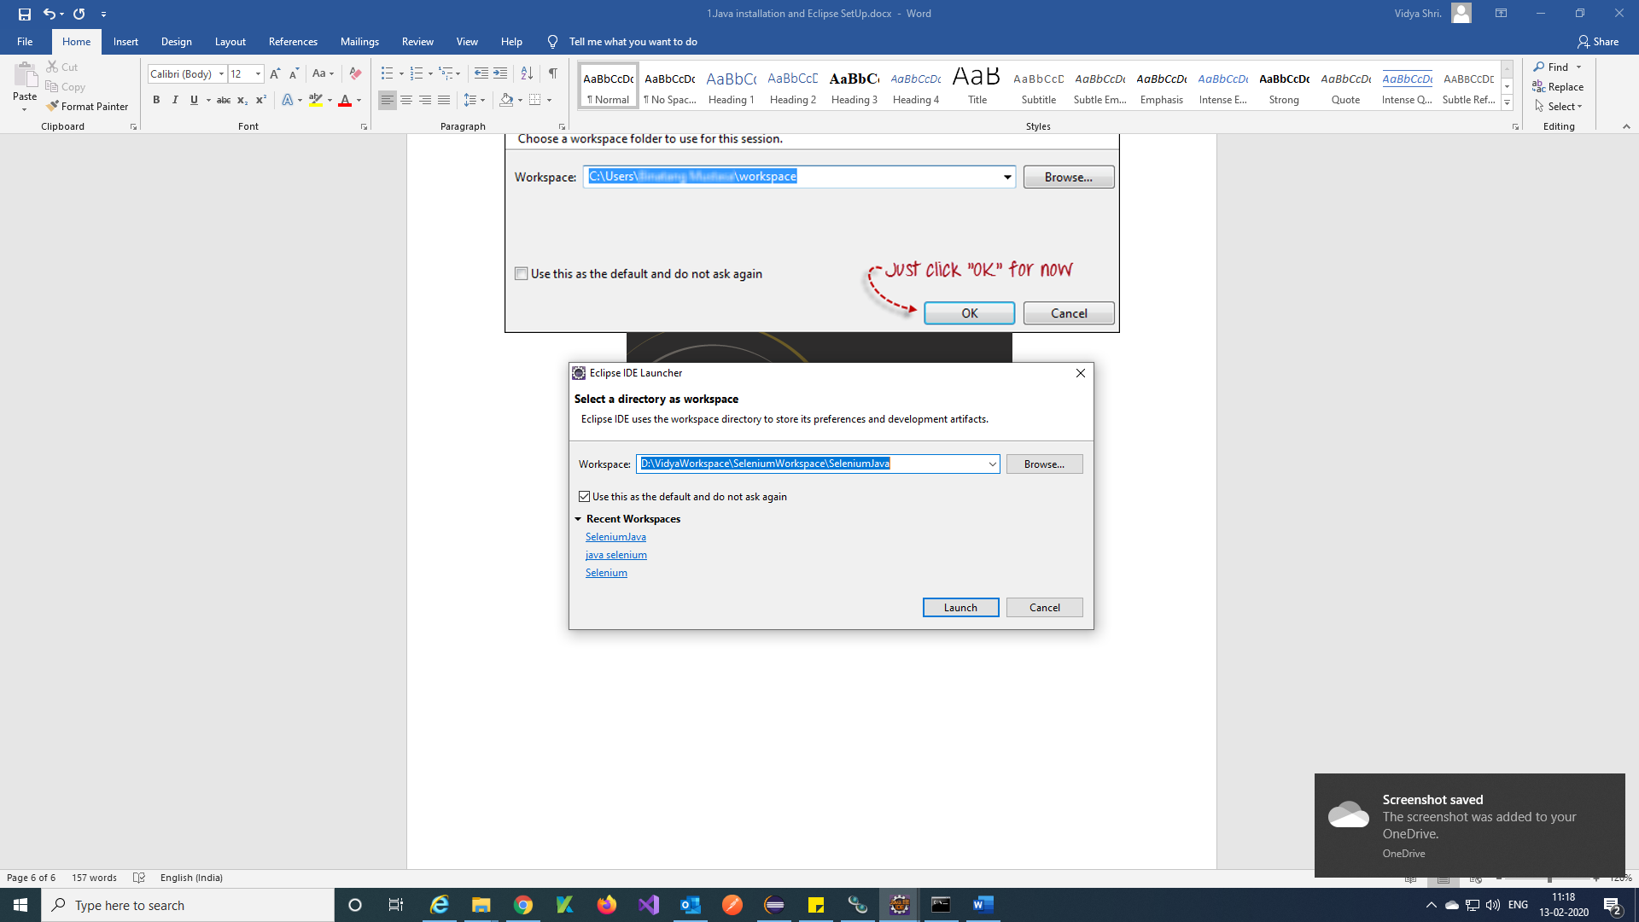

Step 4) You will get this window.

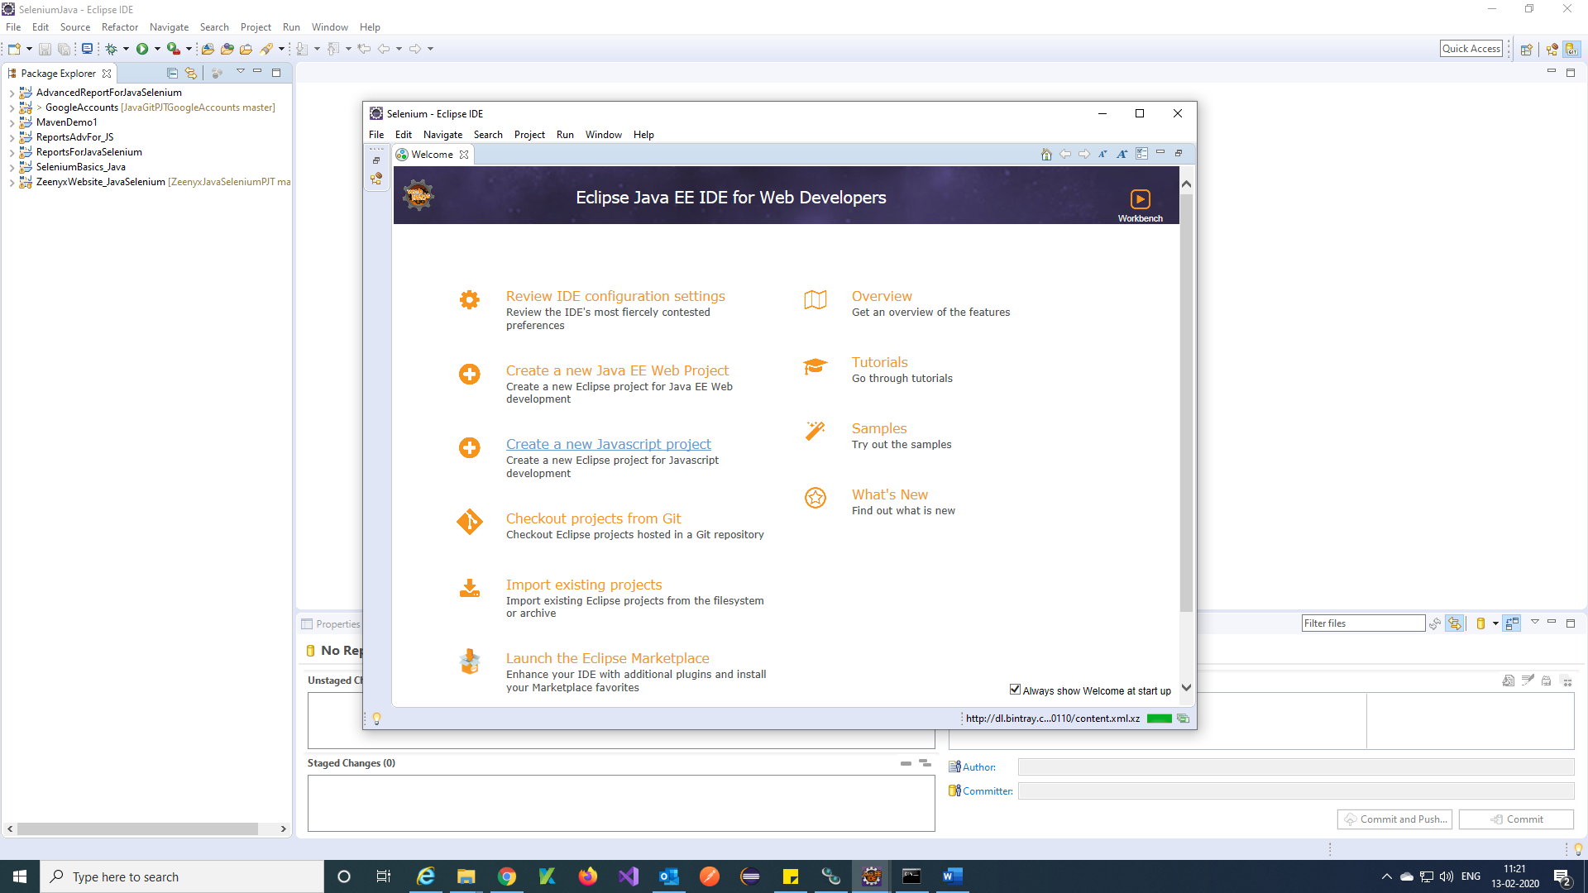

Note: We used Eclipse version is

